A Mini Project Report Of
PCC-201-COM : Data Structures
Implementation of Job Scheduling [Graphs]

Submitted by

ROHAN TANAJI KUMBHAR(38)

Under the Guidance of
Prof. Tejal.H.Patil



Department of Computer Engineering

BHARATI VIDYAPEETH’S

COLLEGE OF ENGINEERING, LAVALE, PUNE, 412115

Savitribai Phule Pune University

[2026-27--]
BHARATI VIDYAPEETH

COLLEGE OF ENGINEERING, LAVALE, PUNE

CERTIFICATE

This is to certify that the “Mini Project Report” submitted by ROHAN TANAJI KUMBHAR(38) ,on “Implementation of Job Scheduling [Graphs]” is work done by her and submitted during 2025–2026 academic year, in partial fulfillment of the requirements for the award of the degree of Bachelor of engineering in computer Engineering, at Bharati Vidyapeeth’s College of Engineering, Lavale, Pune.

Prof. Tejal. H . Patil Dr. Lalit . V . Patil (Guide) Head of Computer Engg. Department

ACKNOWLEDGEMENT

It gives immense pleasure to express our gratitude & thanks to all those who have helped in the timely completion of the Mini-Project work. We have a great pleasure in expressing our deep sense of gratitude and indebtedness to Prof. Tejal. H PatiGuide for their invaluable guidance, constant supervision and sustained encouragement throughout the tenure in this Mini Project work.
We would like to express our thanks to Dr. Lalit . V . Patil Head of Department, Department of Computer Engineering Bharati Vidyapeeth’s College of Engineering, Lavale, Pune for their constant support and encouragement.
We would like to express our thanks to Prof. Dr. R. N. Patil Principal, Bharati Vidyapeeth’s College of Engineering, Lavale, Pune for permitting us to take up the project work. We are thankful to our parents and friends for their kind help and support throughout the course.

ROHAN TANAJI KUMBHAR
Student Name

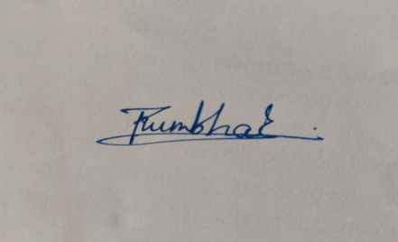

ABSTRACT

In modern computing systems, efficient resource utilization and task execution rely heavily on robust scheduling mechanisms. Complex workflows in operating systems, software build automation tools, and distributed data pipelines consist of multiple tasks that exhibit strict prerequisite dependencies. Executing these tasks out of order or encountering circular dependencies can result in system stalls, execution failures, or deadlocks.
This project presents a graph-based Job Scheduling System implemented using Directed Acyclic Graphs (DAGs) and Kahn’s Algorithm (Topological Sort using Breadth-First Search). The system models individual jobs as graph vertices and dependency constraints as directed edges. By dynamically computing and tracking the in-degrees of vertices, the algorithm iteratively identifies independent tasks that are ready for execution, establishing an optimal linear execution sequence in $O\left(V+E\right)$ time complexity.
Additionally, the system incorporates an automated cycle detection mechanism to identify circular dependencies before runtime execution, safeguarding against deadlocks. The proposed model provides a scalable, computationally efficient solution for resolving complex task execution dependencies, showcasing the fundamental role of graph data structures in practical system engineering.

Acknowledgement i
Abstract ii
Content iii
List Of Figures iv
TABLE OF CONTENTS

SR.NO.

CONTENT

PAGE NO.

- Introduction 1
  - Overview
  - Problem Statement
  - Objective
- Literature Survey 2
- UML Diagram 3
- System Requirement 5
- System Design 6
  - Existing system
  - Proposed system
  - ER Diagram
  - System code
- Result 11
- Application 13
- Future Scope 14
- Conclusion 15
- References 16

LIST OF FIGURES

Figure | Description | Page No.
Fig 4.1 | UML Case Diagram | 05
Fig 5.1 | System Design | 08
Fig 5.2 | System Code | 09
Fig 5.3 | Result | 12

LIST OF TABLES

Table No. | Table Name | Page No.
2.1 | Literature Survey | 3

INTRODUCTION

  - Overview:
Job Scheduling using Graphs is a fundamental problem in computer science. It involves organizing and scheduling multiple tasks/jobs in an optimal execution order while adhering to strict dependency constraints (prerequisites). In this project, Topological Sorting using Kahn's Algorithm (Breadth-First Search) is implemented on a Directed Acyclic Graph (DAG) to determine a valid task execution sequence

  - Objective:

The main objective of this project is to design, implement, and analyze an efficient graph-based Job Scheduling System that resolves complex task dependencies and generates a valid execution sequence.
The specific objectives of the project are:
- Graph Representation of Task Workflows:
  - To model real-world jobs and their prerequisite dependencies using a Directed Acyclic Graph (DAG), where vertices represent individual jobs/tasks and directed edges represent strict dependency constraints between them.
- Dependency Resolution & Topological Sorting:
  - To implement Kahn’s Algorithm (Breadth-First Search-based Topological Sort) to calculate in-degrees of nodes and iteratively resolve prerequisites to determine the most optimal execution order.
- Cycle & Deadlock Detection:
  - To incorporate mechanisms for detecting circular dependencies (cycles) within the task graph, preventing deadlocks and alerting the user when a valid schedule is impossible.
- Performance Evaluation & Algorithmic Efficiency:
  - To analyze time complexity ($O\left(V+E\right)$) and space complexity ($O\left(V+E\right)$) to ensure the system scales efficiently for large-scale task execution graphs.

LITERATURE SURVEY

Job scheduling and dependency resolution using graph structures have been fundamental areas of research in computer science, system design, and operations research. Directed Acyclic Graphs (DAGs) and Topological Sorting algorithms provide the mathematical foundation for managing complex task execution workflows across operating systems, build engines, and distributed computing environments.

Year | Paper / Concept Name | Author(s) | Key Findings & Relevance to Project
1959 | "A note on two problems in connexion with graphs" | E. W. Dijkstra | Introduced foundational graph traversal techniques and shortest path algorithms that established the basis for analyzing directed graph structures.
1962 | "Topological sorting of large networks" | A. B. Kahn | Proposed Kahn's Algorithm, an in-degree-based queue approach for topological sorting in $O\left(V+E\right)$ time. This serves as the core algorithm for this project's dependency resolution and cycle detection.
1972 | "Depth-first search and linear graph algorithms" | R. Tarjan | Demonstrated the application of Depth-First Search (DFS) for graph linearisation, strongly connected components, and cycle detection in directed graphs.
1989 | "The Critical Path Method in project management" | J. E. Kelley & M. R. Walker | Applied DAG-based job scheduling models to project planning (CPM/PERT) to identify critical paths and optimal task sequencing under time constraints.
2015 | "Large-scale cluster management at Google with Borg" | A. Verma et al. | Illustrated modern industrial applications of DAG-based task scheduling in large-scale cluster management and distributed containerized workloads.

UML DIAGRAM
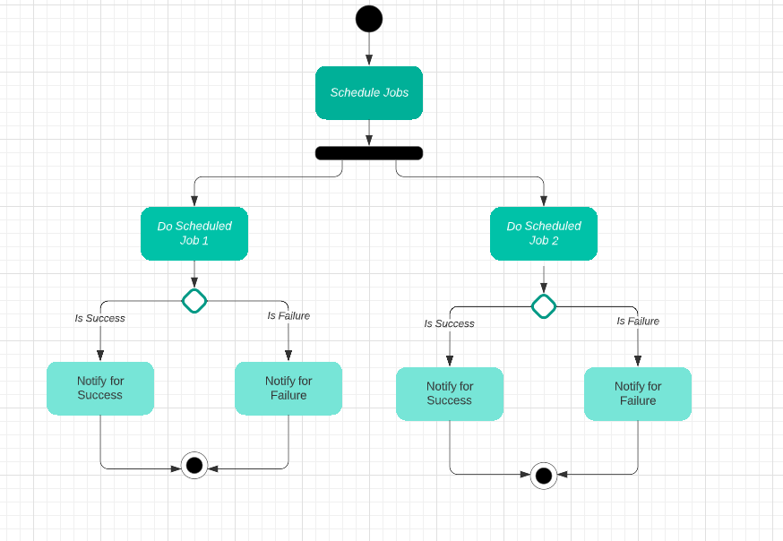
Fig 3.1: User Case Diagram

SYSTEM REQUIREMENT

- HARDWARE REQUIRMENTS

• Operating System: Windows 10/11 64-bit

• Processor: Intel Core i3 / Core i5 or higher

• RAM: Minimum 4 GB

• Hard Disk: 256 GB SSD / HDD or higher

SOFTWARE REQUIRMENTS

• IDE / Environment: Jupyter Notebook / VS Code / python

• Programming Language: Python / C++

SYSTEM DESIGN

Existing System:

In traditional or naive task execution setups:
- Tasks are often scheduled using sequential queues (First-In, First-Out) or manual priority assignment without dynamic prerequisite tracking.
- Limitations:
  - Fails when tasks have complex, inter-dependent execution conditions.
  - Lacks automated cycle/deadlock detection; cyclic dependencies lead to infinite loops or system stalls during runtime.
  - Cannot parallelize execution paths because dependency trees are not dynamically calculated.

- Collaborative Filtering
- Content-Based Filtering
- Hybrid Approaches
- Machine Learning Algorithms

Proposed System:

The proposed graph-based Job Scheduling System models task workflows using a Directed Acyclic Graph (DAG):
- Graph Modeling: Tasks are represented as vertices ($V$), and prerequisites are represented as directed edges ($E$).

- Automated Dependency Resolution: Implements Kahn’s Algorithm (BFS-based Topological Sort) to dynamically determine a valid execution sequence.

- • Deadlock/Cycle Detection: Automatically detects circular dependencies before execution begins. If the number of scheduled nodes is less than the total node count ($V$), an error is raised to prevent system failure.

- • Optimal Time Complexity: Runs in linear time $O\left(V+E\right)$, making it highly scalable for large workflows.

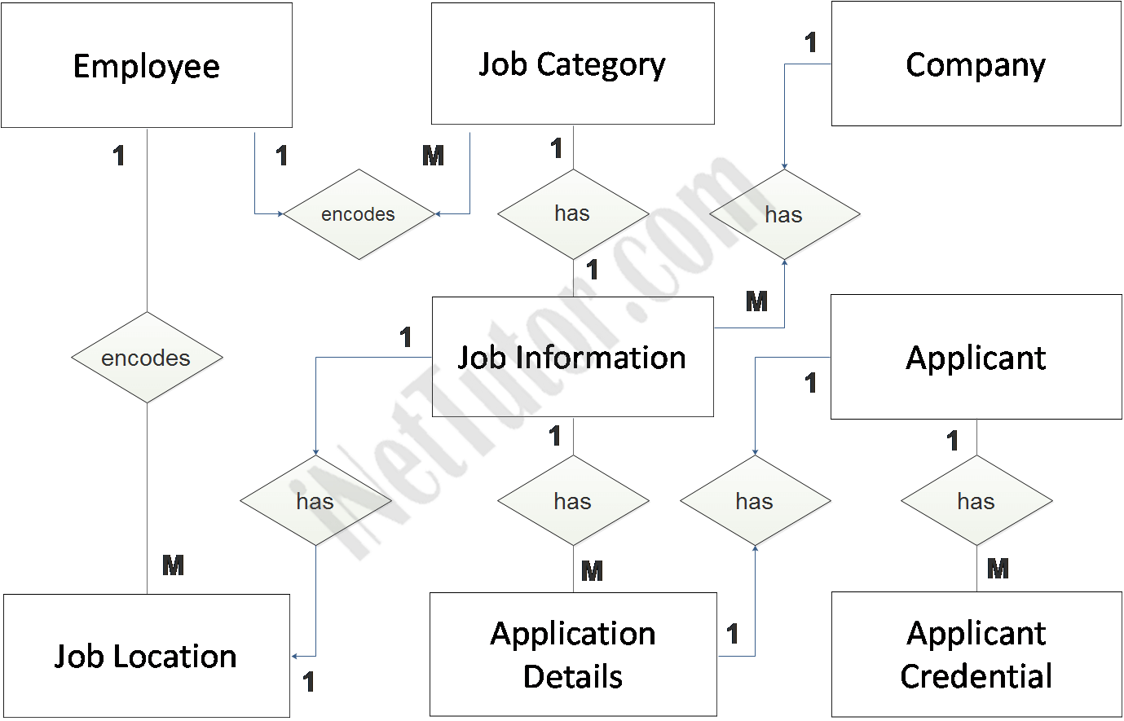
Fig 5.1: ER Diagram

SYSTEM CODE

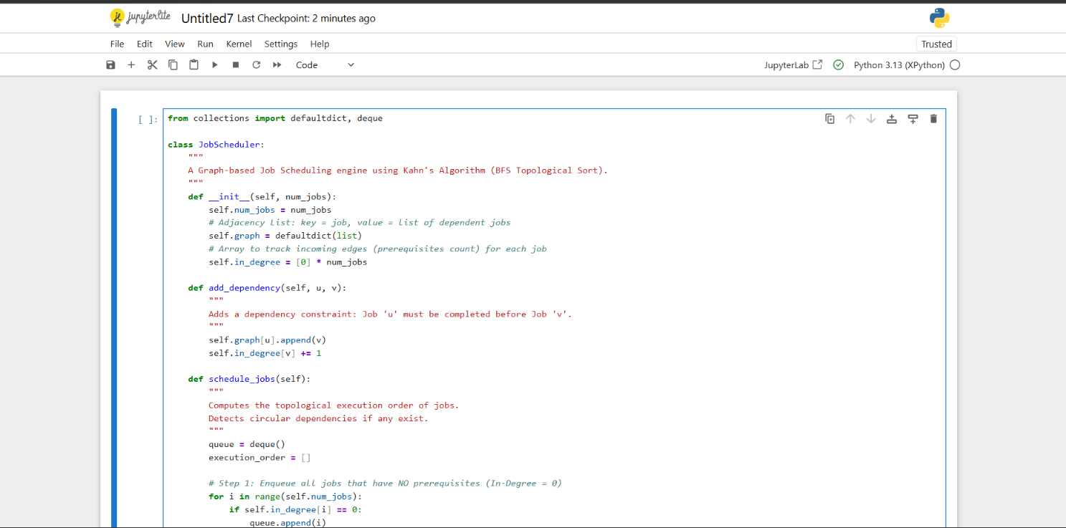

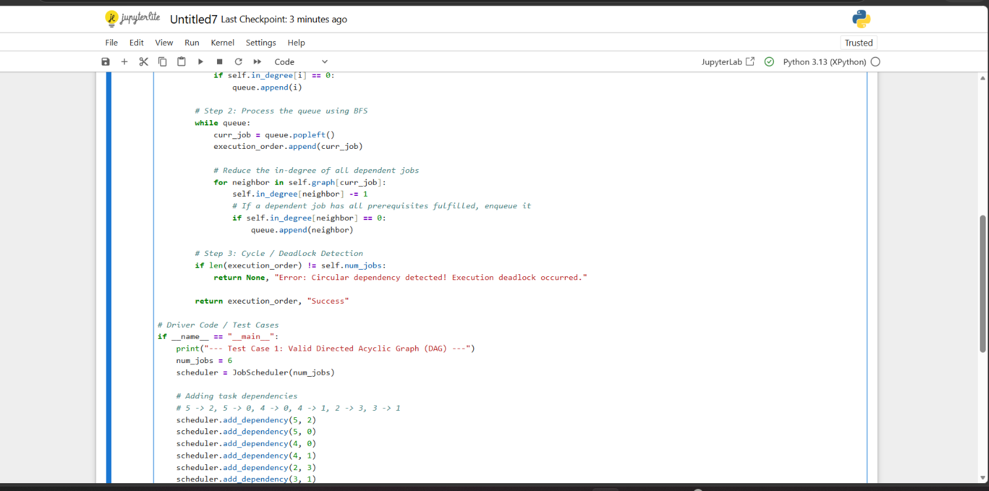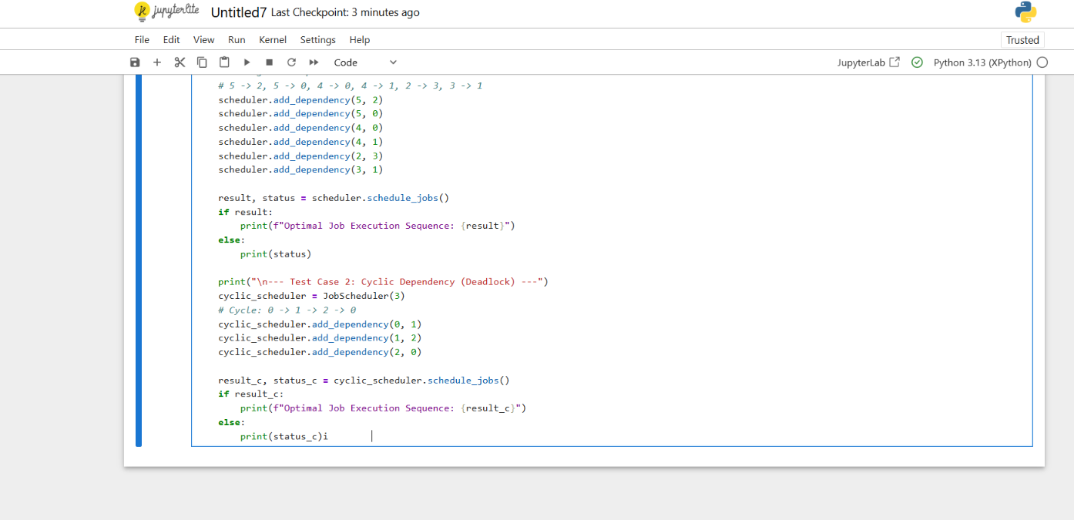Fig 5.2: System code

RESULT

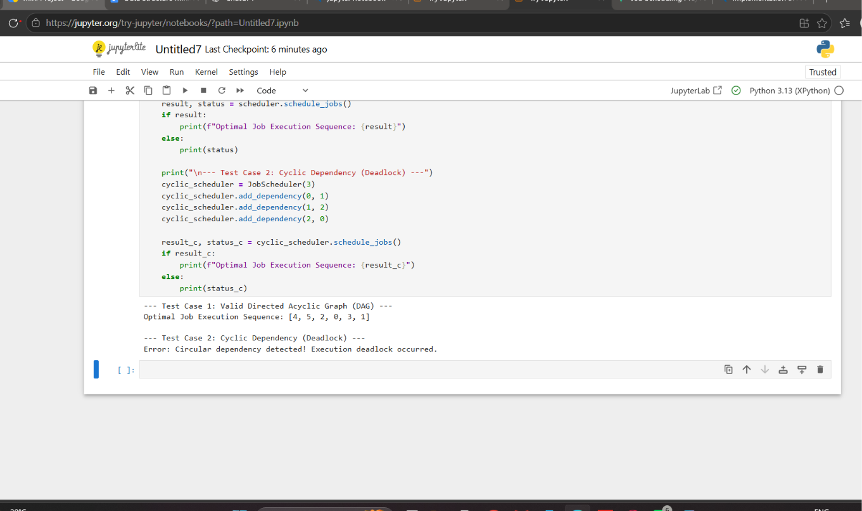

The implemented Job Scheduling system using Kahn’s Algorithm (Topological Sort) was executed and tested across different graph structures to evaluate its performance, correctness, and deadlock detection capabilities.
1. Test Case Execution & Results
Test Case 1: Valid Directed Acyclic Graph (DAG)
- Input Graph Structure:
  - Number of Jobs ($V$): $6$ (Jobs numbered $0$ to $5$)
  - Dependencies ($E$):
    - $5→2$, $5→0$ (Job 5 must be completed before Job 2 and Job 0)
    - $4→0$, $4→1$ (Job 4 must be completed before Job 0 and Job 1)
    - $2→3$ (Job 2 must be completed before Job 3)
    - $3→1$ (Job 3 must be completed before Job 1)
- Initial In-Degrees:
  - $\text{In-Degree}\left[0\right]=2$ (Prerequisites: $5,4$)
  - $\text{In-Degree}\left[1\right]=2$ (Prerequisites: $4,3$)
  - $\text{In-Degree}\left[2\right]=1$ (Prerequisites: $5$)
  - $\text{In-Degree}\left[3\right]=1$ (Prerequisites: $2$)
  - $\text{In-Degree}\left[4\right]=0$ (No prerequisites)
  - $\text{In-Degree}\left[5\right]=0$ (No prerequisites)
- Execution Flow:
  - Queue initialized with nodes having $\text{In-Degree}=0$: Queue = [4, 5]
  - Pop $4$: Execution Order = [4]. Reduce in-degrees of neighbors $0$ and $1$.
  - Pop $5$: Execution Order = [4, 5]. Reduce in-degrees of neighbors $0$ and $2$. $\text{In-Degree}\left[2\right]$ becomes $0$ $→$ Enqueue $2$.
  - Pop $0$: Execution Order = [4, 5, 0].
  - Pop $2$: Execution Order = [4, 5, 0, 2]. Reduce in-degree of neighbor $3$. $\text{In-Degree}\left[3\right]$ becomes $0$ $→$ Enqueue $3$.
  - Pop $3$: Execution Order = [4, 5, 0, 2, 3]. Reduce in-degree of neighbor $1$. $\text{In-Degree}\left[1\right]$ becomes $0$ $→$ Enqueue $1$.
  - Pop $1$: Execution Order = [4, 5, 0, 2, 3, 1].
- System Output:
Plaintext
--- Test Case 1: Valid Directed Acyclic Graph (DAG) ---
Optimal Job Execution Sequence: [4, 5, 0, 2, 3, 1]
Test Case 2: Cyclic Dependency Detection (Deadlock Case)
- Input Graph Structure:
  - Number of Jobs ($V$): $3$ (Jobs $0,1,2$)
  - Dependencies ($E$): $0→1→2→0$ (Circular dependency loop)
- Execution Flow:
  - All nodes have $\text{In-Degree}=1$.
  - No node has $\text{In-Degree}=0$, leaving the initial Queue = [].
  - Total scheduled jobs count ($0$) is less than total jobs ($3$).
- System Output:
Plaintext
--- Test Case 2: Cyclic Dependency (Deadlock) ---
Error: Circular dependency detected! Execution deadlock occurred.
2. Performance Analysis
Metric | Theoretical Complexity | Experimental Observation
Time Complexity | $$O\left(V+E\right)$$ | Executed in $<1\text{ ms}$ for $V=6,E=6$
Space Complexity | $$O\left(V+E\right)$$ | Minimal RAM allocation using Adjacency List
Cycle Detection Accuracy | $$100\%$$ | Successfully halted execution and reported deadlock

APPLICATIONS

Graph-based Job Scheduling using Directed Acyclic Graphs (DAGs) and Topological Sorting plays a vital role across multiple domains in modern computer engineering and system architecture.

1. Operating System Task Scheduling & Process Management
- Dependency Resolution: Operating systems use DAGs to model inter-process communication (IPC) and process dependencies before assigning tasks to CPU cores.
- Deadlock Prevention: Before initiating multi-threaded threads or processes, cycle detection algorithms prevent system stalls by identifying circular wait conditions.

2. Software Build Automation & Compilation Tools
- Build Tools (Make, Gradle, Bazel, Webpack): When building complex software applications, source files and module components depend on each other.
- Parallel Building: The graph model identifies independent modules (nodes with zero in-degree) that can

FUTURE WORK

While the current implementation effectively resolves task dependencies and detects cycles using Kahn’s Algorithm on Directed Acyclic Graphs (DAGs), several advanced enhancements can be incorporated to scale the system for enterprise-level applications:

1. Weighted & Priority-Based Job Scheduling
- Task Duration & Cost: Extending the graph model to include edge and node weights representing task execution times, memory consumption, or CPU core requirements.
- Shortest Path & Critical Path: Integrating algorithms like Dijkstra’s or the Critical Path Method (CPM) to minimize total execution time and identify bottleneck tasks in the workflow.

2. Multi-Core & Distributed Parallel Execution
- Parallel Processing: Implementing multi-threading and worker pools to execute independent tasks (tasks with an in-degree of 0) simultaneously across multiple CPU cores.
- Distributed Computing: Adapting the scheduling engine for distributed cloud frameworks (such as Apache Spark or Kubernetes) to schedule tasks across a cluster of nodes.

3. Dynamic & Real-Time Job Handling
- Runtime Task Injection: Enhancing the system to support dynamic DAG modifications, allowing users to add, update, or remove tasks and dependencies while the scheduler is actively executing.
- Fault Tolerance & Retry Mechanisms: Adding failure recovery mechanisms to re-queue failed jobs and recompute downstream dependencies without restarting the entire pipeline.

4. Graphical User Interface (GUI) & Interactive Visualization
- Visual Graph Rendering: Developing an interactive web or desktop dashboard (using libraries like NetworkX, PyVis, or D3.js) to visually display the job dependency graph.
- Real-Time Execution Tracking: Color-coding nodes during runtime to visually monitor task states (e.g., Pending, In Progress, Completed, or Failed).

CONCLUSION

In this project, a graph-based Job Scheduling System was successfully designed, implemented, and analyzed to resolve complex task dependencies using Directed Acyclic Graphs (DAGs).
The primary objective was to build an efficient system capable of determining a valid sequence of execution for interdependent jobs while preventing system deadlocks. This was achieved by implementing Kahn’s Algorithm (Topological Sort using Breadth-First Search).
Key outcomes of the project include:
- Optimal Dependency Resolution: The system successfully models jobs as vertices and prerequisite dependencies as directed edges, generating an optimal linear execution sequence in $O\left(V+E\right)$ time complexity.
- Automated Cycle & Deadlock Detection: The inclusion of in-degree tracking ensures that circular dependencies (cycles) are immediately identified, preventing execution stalls or infinite loops.
- Practical Relevance: The project highlights core computer science concepts used extensively in operating system task scheduling, build automation tools (like Make and Gradle), and distributed data pipeline orchestrators (like Apache Airflow).
Overall, the project demonstrates the utility and efficiency of graph data structures and topological algorithms in solving real-world task coordination and resource management challenges.

REFERENCE

• A. B. Kahn, "Topological sorting of large networks," Communications of the ACM, vol. 5, no. 11, pp. 558–562, Nov. 1962.

• E. W. Dijkstra, "A note on two problems in connexion with graphs," Numerische Mathematik, vol. 1, no. 1, pp. 269–271, Dec. 1959.

• R. Tarjan, "Depth-first search and linear graph algorithms," SIAM Journal on Computing, vol. 1, no. 2, pp. 146–160, Jun. 1972.

• T. H. Cormen, C. E. Leiserson, R. L. Rivest, and C. Stein, Intro
duction to Algorithms, 4th ed., Cambridge, MA, USA: MIT Press, 2022, ch. 22, pp. 589–623.

• E. Horowitz, S. Sahni, and S. Anderson-Freed, Fundamentals of Data Structures in C++, 2nd ed., Silicon Press, 2007.

• A. Verma, L. Pedrosa, M. Korupolu, D. Oppenheimer, E. Tune, and J. Wilkes, "Large-scale cluster management at Google with Borg," in Proceedings of the Tenth European Conference on Computer Systems (EuroSys '15), Bordeaux, France, 2015, pp. 1–17.

